

Department of Electrical and Electronic Engineering

CPT106(S2) C++ Programming and Software Eng. II

CPT106 C++ Programming Report

Name :Tiankuo.Jiao

Student ID :1929098
Abstract

For this task, we have done the best fit line algorithm design. After the user enters the coordinates of several points, the program can show the corresponding best fit line based on these coordinates. In mathematical analysis, the best line can be used to approximate the distribution of coordinate points, and we can use the best line to represent these points.

After getting the equation of the best line, we also calculate the distance from each coordinate point to the line according to the formula. Moreover, according to the distance, we find the best and the worst points. Finally, we calculate the standard error of distance for all the points.

In the program, we also realize the operation of reading all the coordinates which have been saved in the file. Moreover, we realize the function of checking whether the coordinate point is in the file or not. And if the coordinate point is in the file, the position of the coordinate point will be displayed. Under the condition that the coordinate point is in the file, delete the coordinates, etc.

In addition, for the possible input errors, we have also taken them into account. If the user wants to delete a point, but the point is not in the file, the program will also tell the user about the problem. Additionally, the user may repeatedly or wrongly enter the coordinate of the point, and the system will prompt the user to the problem of repeating or wrong input. On the main interface, the user may type letters or type the numbers which may be beyond the range of 1 to 10, the program will tell the user that the input was wrong and request a retype.

Catalogue

Abstract 2
1.Specification (Problem statement) 4
1.1 Line fitting algorithms 4
1.2 Specific algorithm of linear fitting 4
1.3 The method of calculating the distance 5
1.4 The standard error 5
1.5 Assessment requirements 5
1.6 Users entered the information incorrectly 6
2.Analysis 6
2.1 On an input 6
2.2 On an output 7
2.3 Variables 7
2.4 Class 8
2.4.1 File stream 8
2.4.2 Two classes designed in the program 8
2.5 Algorithm 9
3.Design 10
3.1 The design for the main function 10
3.1.2 Flow chart of the main function 11
3.2 The design for the algorithm 11
3.2.1 The flow chart for the best fit line 12
3.2.2 The design for the check and delete functions 12
3.2.3 The flow chart of checking point 13
4.Test 14
4.1 The main function of the program 14
4.2 Input error part 18
5.Implementation 18

- Specification (Problem statement)

1.1 Line fitting algorithms

In this Assessment, we need to design an algorithm for line fitting. If we are given a set of coordinates (x, y), we need to automatically calculate the equation of the best line through the data. This type of analysis of points is called line fitting or regression analysis.

1.2 Specific algorithm of linear fitting
Firstly, we assume the equation for a straight line is：

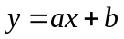 (1)

Additionally, if we have input n points of  values.
Therefore, we can use the formula:

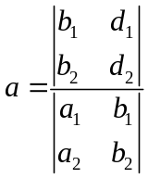 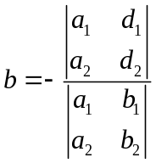 (2)
Where,
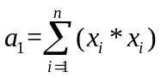 (3)
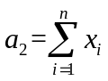
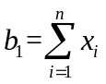,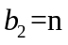 (4)
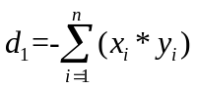 (5)
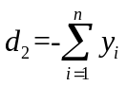 (6)

1.3 The method of calculating the distance
We assume a point 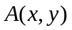，the equation of the line is: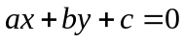
Through these conditions, we can calculate the distance:
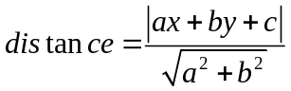
1.4 The standard error
For all points, the standard error is:

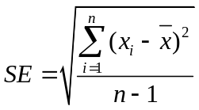

1.5 Assessment requirements
According to the requirements, we need to design a File Operation Class that allows the user to enter points (x,y) from the keyboard and save those points to a text File. And the program can read those points from the text file, checking whether the points are in the file. And if the points are in the file, we can choose to delete them. Moreover, the program needs to print the equation of the best fitting line to the users.

If desired, the user can enter a point and print out whether it is in a text file. Additionally, we also need to find the best point (the closest distance from the line) and the worst point (the farthest distance from the line). And we also need to calculate the standard error and print the standard error for all the points.
1.6 Users entered the information incorrectly
Although we have indicated the range of input, users may still input the wrong character. Here are the conditions that the user inputs the wrong character:

1.In the main interface, we set up a total of 10 options, each number represents a different function, the user may enter a number that is not in the range of 1-10 or enter a letter. At this point, we need to tell the users the error and let the users to re-input the number.

2.When entering the coordinates, the user needs to enter the x-axis coordinates and the y-axis coordinates respectively. The user may have entered a non-number, and the program needs to tell the users the error and let the users re-input it.

3. Because I save the file in Disk D, if the user does not have disk D, the file cannot be created, and the user needs to choose the appropriate file address to save.

- Analysis

This time we need to design a Line fitting algorithms. Through the multiple points provided, the best fitting line will be determined. At the same time, the user can also input a point, check whether the input point is in the file. If the point is in the file, the user can choose to delete it. Finally, we need to ask the program to determine the best and worst points, which correspond to the nearest and farthest points of the best fitting line.

2.1 On an input
In this task, the user is required to enter the coordinates of multiple points, including the x-axis and y-axis coordinates of each point.
After inputting the coordinates of several points, we can carry out fitting line calculation according to the input coordinates, calculate the values of a,b according to the above formula.
Through the value of a,b, we can finally get the best fit line equation. If desired, the user can know the distance between each point and the line. Moreover, the user can select the function to check whether the input point is already in the file or not. If the point is not in the file, the program needs to tell the user. In addition, the user can also delete the unwanted point if the point is in the file.

2.2 On an output
After the user enters several coordinates, the program needs to calculate the best fit line through the above algorithm. The equation for the best fit and straight line is: y=ax+b. The program needs to calculate the values of a and b through the algorithm and show the equation of the line to the user. At the same time, we also need to calculate the distance from each point to the line through the formula above.
The user can view the point that is in the file, and if the user enters a new point that is the same as the point in the file, we need to tell the user the location of the point. If the user chooses to calculate a Standard error, the user can choose this function.
In addition, if the user chooses to delete a point, the program will first check to see whether the point is in the file or not. And if it is in the file, then the user can choose to delete the point.

While showing the best fit line, we also need to show the best point and the worst point to the user (these two points are the nearest and farthest points from the best fit line respectively).

2.3 Variables
In the algorithm of the best fit line, we need to find the values of a and b and substitute a and b into the equation of the line. Similarly, when calculating the distance from the point to the best fit line, according to the formula
(1)
We need to use new a, b and c to calculate. When calculating the standard error, we designed “avg” and “sum1” variables. We design variables x1 and y1 to check whether the point is in the file

2.4 Class

2.4.1 File stream
There are three classes in the C++ standard class library that can be used for file operations, collectively called file stream classes. The three classes are:

• 1.ifstream: Used to read data from a file.
• 2.ofstream: Used to write data to a file.
• 3.fstream: Used to read data from a file and write data to a file.

To use these three classes, the program needs to include the head file <fstream>. In the program, we first need to open the file before reading and writing. Additionally, we need to close the file after reading and writing. Moreover, creating a new file also requires an open operation before data written to the file. C++ file stream classes have corresponding member functions to open, read, write, close, and other file operations.

2.4.2 Two classes designed in the program
We have designed two classes, Class Fileop and Class Linefiting.
In Class Fileop, we write several functions:

InputPoint();//Add a point
ReadPoint();//Read the point from the file
DelPoint();//Delete the point
FindPoint();//Check whether the point is in the file

In Class Linefiting，we also write several functions about the best fit line:

OutBestLine();//To get the best line
PointDistance();//The distance between the point and the line
BestDistance();//The distance of the best point
WorstDistance();//The distance of the worst point
NormDistance();//The standard error

2.5 Algorithm
According to the requirements, we calculated the values of a1,a2, b1, b2, d1 and d2 respectively, and calculated the values of a and b according to the formula. Next, we divide the equations into two situations.

The first type, if 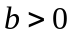,according to this form output:

< < a < < "x - y +" < < < < b = 0 "" < < endl

The second type, if 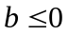, according to this form output:

< < a < <" x-y "< < < < b = 0" "< < endl

When calculating the distance of each point, we use the formula:

- Design

3.1 The design for the main function
In the main function, we need to let the user choose the function they want from the numbers 1-10.

Number 1: User input coordinates

Number 2: Read the points which have been saved in the file

Number 3: The program deletes a point selected by the user

Number 4: Check whether the point is in the file. Tells the user its location if the point is in the file.

Number 5: Calculate the values of a and b and show the best fit line equation.

Number 6: Calculate the distance from each point to the best fit line

Number 7: Find the best point

Number 8: Find the worst point

Number 9: Calculate the standard error of this set of data

Number 10: Exit the program

3.1.2 Flow chart of the main function

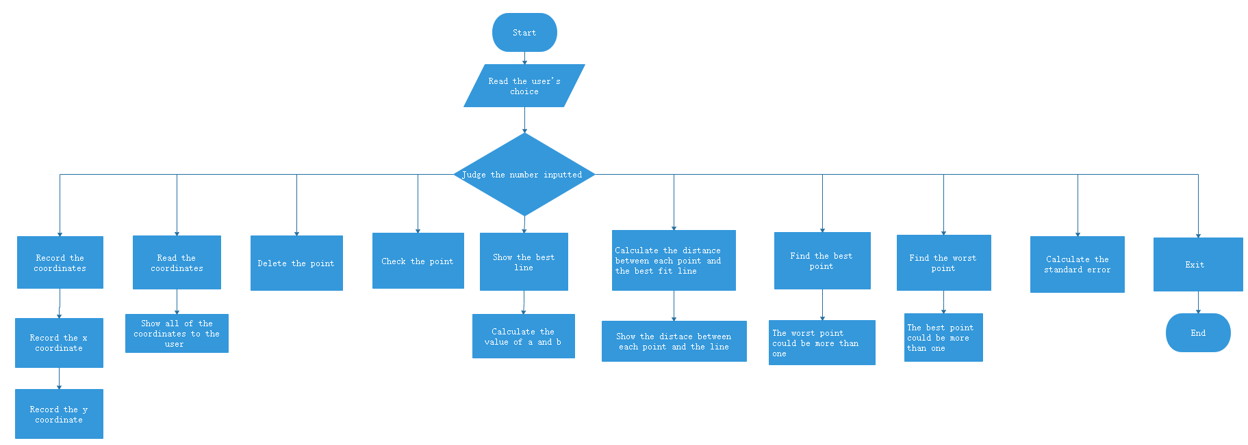

3.2 The design for the algorithm
We first calculated the values of a1, a2, b1, d1 and d2 according to the formula. Moreover, we calculate the values of the best fit lines a and b according to the results and finally figure out the equation of the line.

In calculating the distance between each point and the straight line, I used the algorithm provided by Assessment to solve the problem.

After figuring out the distance from each point to the line, we find the best and worst point by comparing the distance from each point.

And finally, we calculate the standard error.

3.2.1 The flow chart for the best fit line

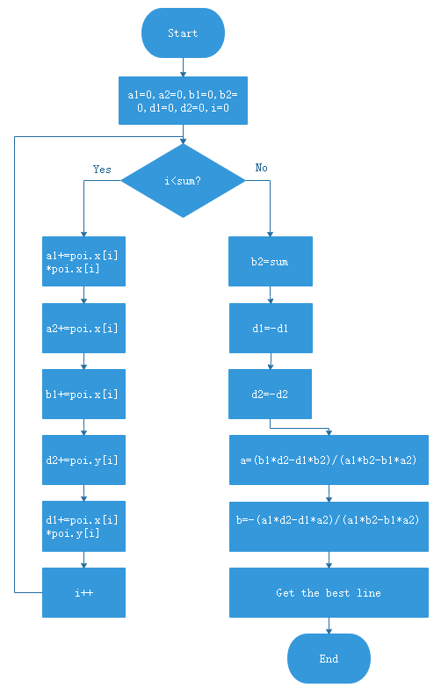

3.2.2 The design for the check and delete functions
According to the requirements, we need to compare the point entered by the user with the point in the file when the user selects the function of checking whether the coordinate point is in the file. If the same point is found, the user will be informed that the coordinate point already exists and the location of the point will be given to the user. Additionally, if the input coordinate point is not in the file, the program will tell the user that the point is not in the file.

For the function of deleting the coordinate point, we first need to check whether the coordinate point is in the file. If the coordinate point is not in the file, the program will tell the user that the coordinate point is not in the file and cannot be deleted. If the coordinate point is in the file, the program will delete the coordinate point in the file.

3.2.3 The flow chart of checking point (if the point is in the file, the user can choose to delete it)

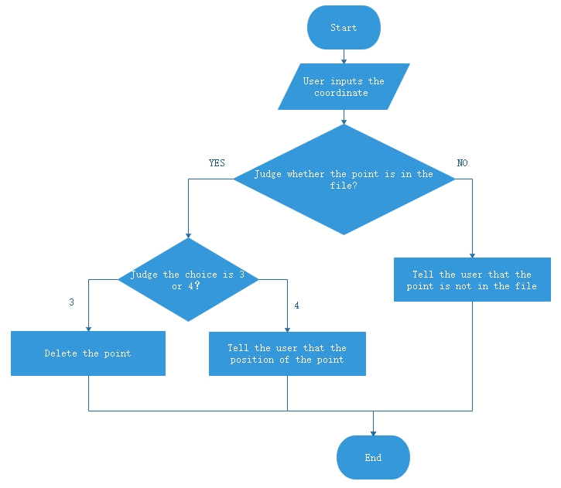

4.Test

4.1 The main function of the program

Test 1
The main interface of the program
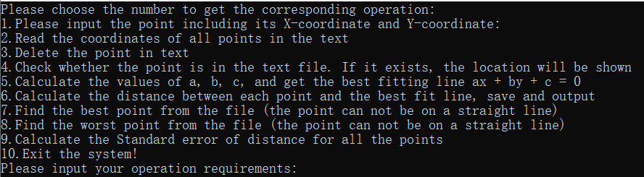

Test 2
The user enters the correct coordinates.
For example, enter (1,1)

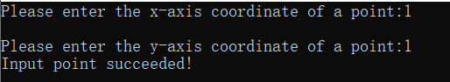

Test 3
When the user repeatedly enters the coordinates already in the file, such as re-entering (1,1), the system will tell the user that this point already exists in the file.
Where, (1,1) is the fifth input

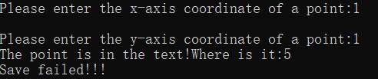

Test 4
The user wants to check whether the point is in the file. If the point is in the file, then print its position.
Where, (1,1) is the fifth input.

Test 5
The user reads the coordinates saved in the file, such as (1,1) (123,150) (130,160) (141,175),(150,190),(165,205)

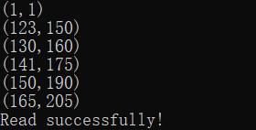

Test 6
The users want to delete the points which have already stored in the file, for example (1,1)
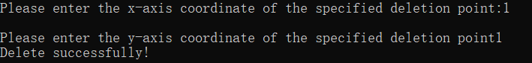

Test 7
If the user wants to delete the point (2,2) that is not in the file, the system will tell the user that this point does not exist in the file, and the deletion fails
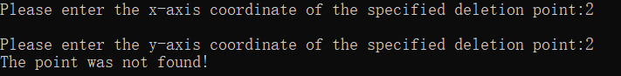

Test 8
The user wants to obtain the equation of the best fit line. Now the points in the file are :(123,150) (130,160) (141,175),(150,190),(165,205)

To ensure the accuracy of calculation, I recalculated the best fit lines of these points through the software. The results are as follows:

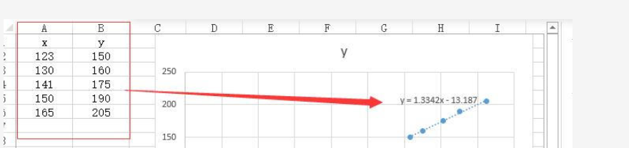

Figure 1: The best fit line for these points

Test 9
The user wants to know the distance from each point to the line
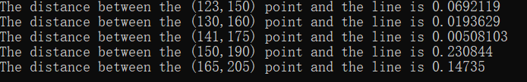
Test 10
Users want to know The Best Point

Test 11
Users want to know The Worst Point
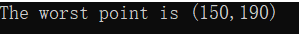
Test 12
Calculate Standard Error of all points:
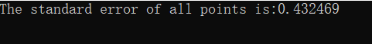
Test 13
Exit Program
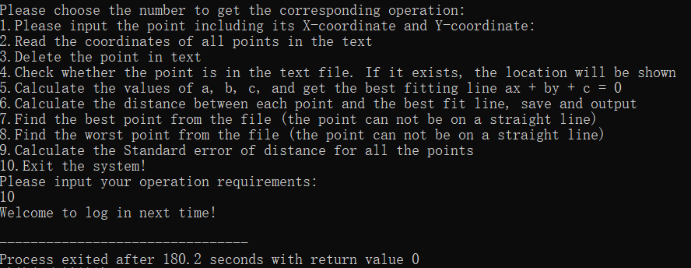

4.2 Input error part

Test 14
If the user inputs characters other than 1-10 in the main interface, the system will let the user enter them again.
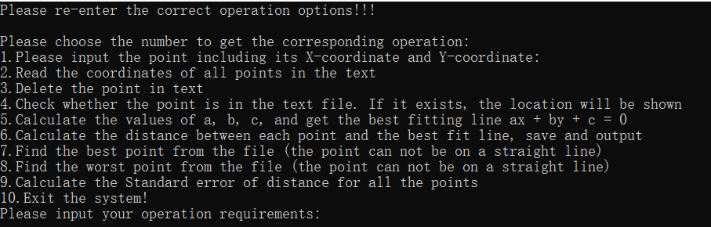

Test 15
When entering coordinates, the user enters non-numbers such as (1, a).
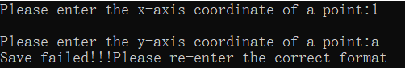
Test 16
File path error, the program will tell the user to open the file failed when we input the coordinate in the program.
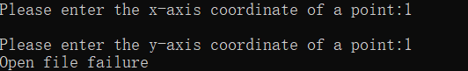
5.Implementation
Tiankuo Jiao 1929098

